page

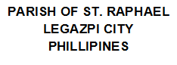

date

book

no

priest

by

year

month

day

name